Elizabeth Hawkins

CIS-245 Linux Administration

Documentation for Grep

9/19/2021

1. Print all lines containing the string Street.

Grep “Street” datebook is the command to use to prints all lines containing the string Street. “Street” is the string you are looking to grep out of the file and datebook is the file you want to grep the word “Street” from. As you can see when I run the command it gives me all the lines containing Street.

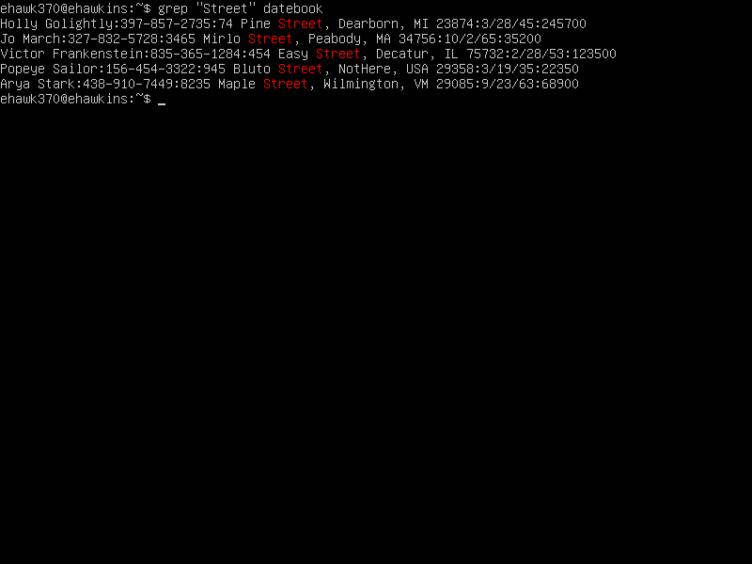

1. Print all lines where the person’s first name starts with M

grep ^ M datebook is the command you use to print all lines of the person’s first name start with M. ^ specifies the start of a line in a file. So, if you are looking for names that begin with a M always use ^ to specify the begin of the line and then just put what you are looking for. As you can see it work it grep all the people’s names whose first name starts with M. As you can see my command work when I ran the command it gave me all the lines whose first names that start with the letter M.

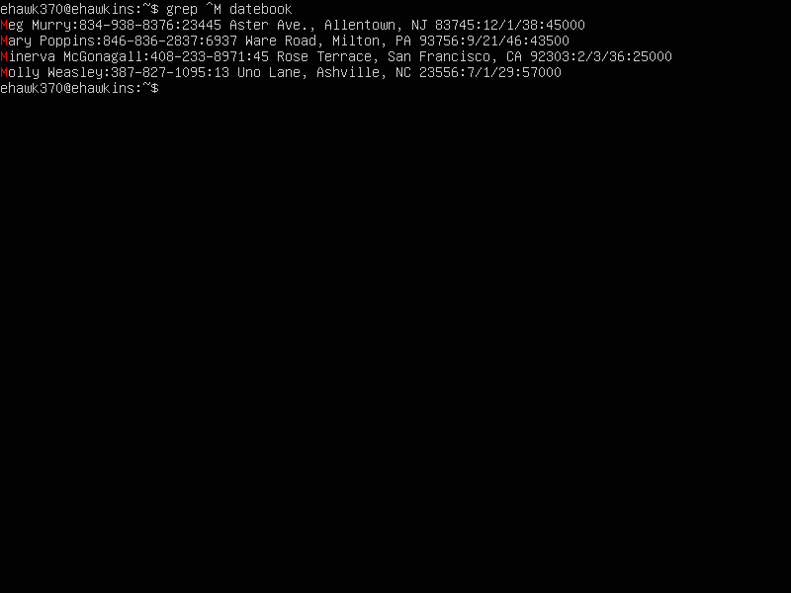

1. Print all lines ending in 000.

grep 000$ datebook is the command to use to prints all lines ending in 000. $ specifies that it is the end of the line. So, if you need to grep lines end in 000 put $ at the end of the number so it knows you are looking for the lines ending with those specific numbers. As you can see when I ran my command it worked and gave me all the lines that end in 000.

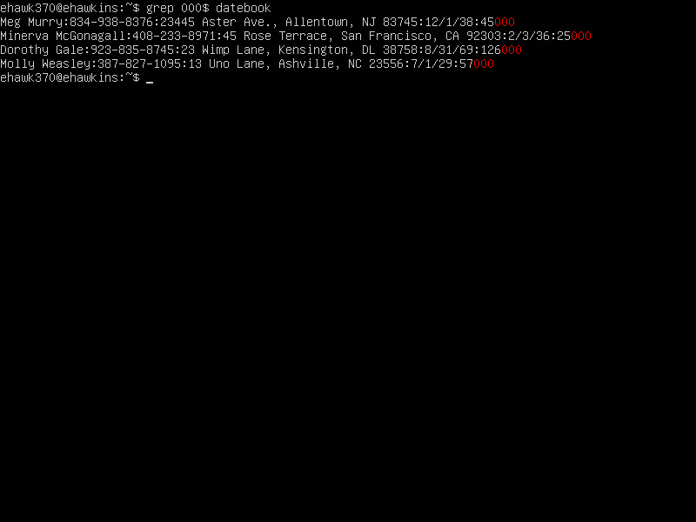

1. Print all lines that do not contain 408.

grep -E -v 408 datebook is the command you use to print all lines that do not contain 408. -E is the extended expression -v prints all line that do not match the expression. 408 is the number you don’t want in your search so by using -v it will take all the numbers out of the search and just show numbers that don’t contain 408. As you can see when I run the command it gives me all lines that don’t contain 408.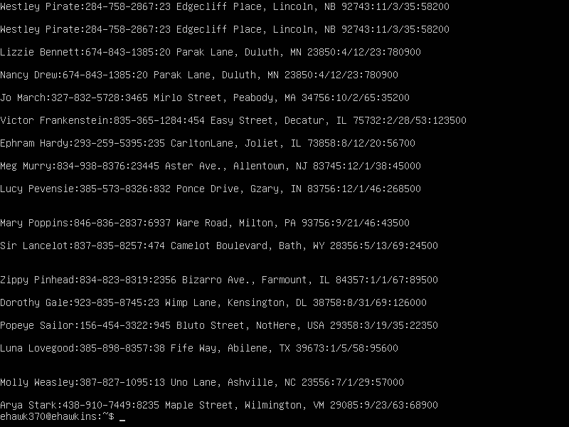

1. Print all lines where birthdays are in the year 1923

grep -E [0-9][0-9]/23 datebook is the command you use to prints all lines whose birthdays are in the year 1923 -E is the extended expression [0-9][0-9] are any number between those numbers /23 is the year they are born in. When I ran the command, you see that I have all the names of the people who are born in 1923. 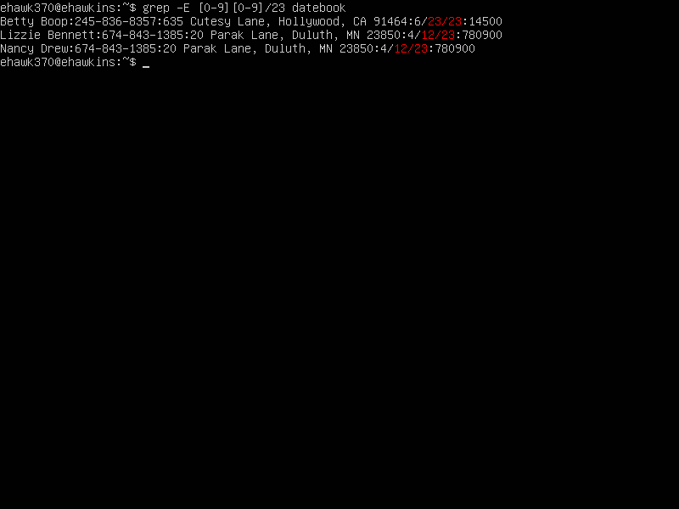

1. Print all lines where the phone number is in an area code that starts with an 8.

grep -E ‘8[0-9]{2}-[0-9]{3}-[0-9]{4}’ datebook is the command you use to print all lines where the phone number is in an area code that starts with an 8. Grep -E is the extended expression ‘8[0-9]{2} is going to be the area code that is going to be starting with an 8. –[0-9]{3} is any numbers from 0-9 and the {3} is the three numbers that come after. –[0-9]{4} is any numbers from 0-9 and the {4} is the last 4 numbers. When I ran the command, it worked. I have all the numbers where the area code begins with an 8.

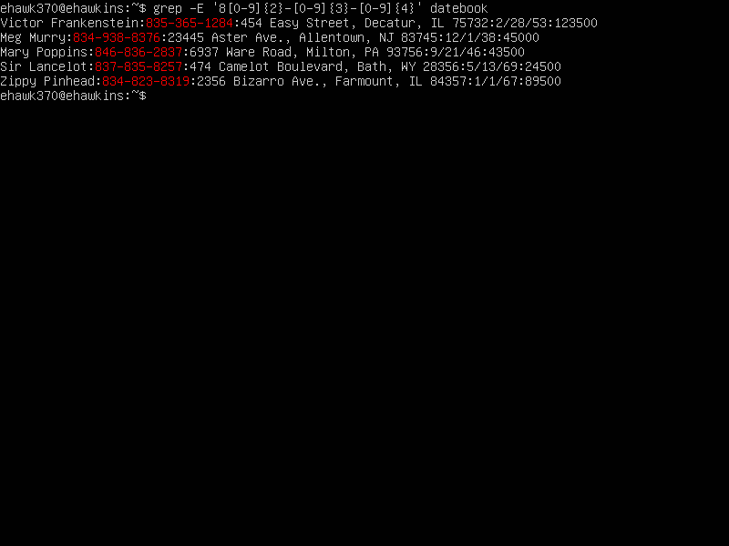

1. Prints all lines containing an uppercase letter, followed by five lowercase letters, a comma, and one uppercase letter.

grep -E “[A-Z][a-z]{5},[A-Z]” datebook is the command you use to print all lines containing an uppercase letter, followed by five lowercase letters, a comma, and one uppercase letter.

-E is the extended expression [A-Z] are upper letters from A-Z. [a-z]{5} are five lowercase letters from a-z.

1. Prints lines where address begins with a two- or three-digit number.

grep -E ‘[0-9][0-9]\{,2\} [A-Z]’ datebook is the command that prints lines where address begins with a two- or three-digit number. -E is the extended expression [0-9] is the numbers you are looking for {,2} are 2-digit numbers no more than 3. When I run the command, it gives me all the address with a 2-3 digit address.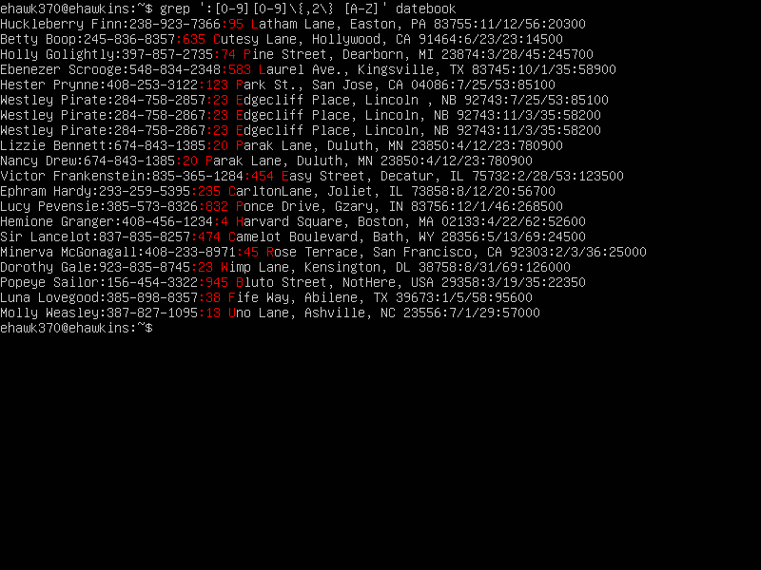

1. Prints lines preceded by a line number where the person is from Massachusetts (or MA)

grep -n -e “Massachusetts” -e “MA” datebook is the command you use to print lines where a person is from Massachusetts or from MA. -n displays the matched lines and their line numbers -e is the regular expression and, in this case, can be used as or with in this case is Massachusetts or MA. As you see when I run my command it gives me all the lines of people who are from Massachusetts or MA.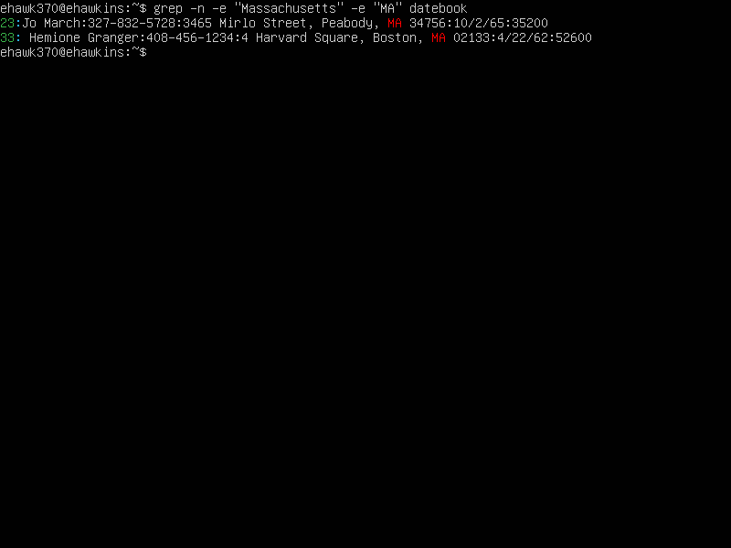

1. Prints lines containing an address that does not include Street or St.

Grep -E -v ‘(Street|St)’ datebook is the command you use to prints all lines containing an address that does not include Street or St. -E is the extended expression -v prints all line that do not match the expression. (Street|St) is what you do not want to be in the search, datebook is the file to search through. As you can seen when I run my command it gives me all the lines that don’t contain the word Street or St.

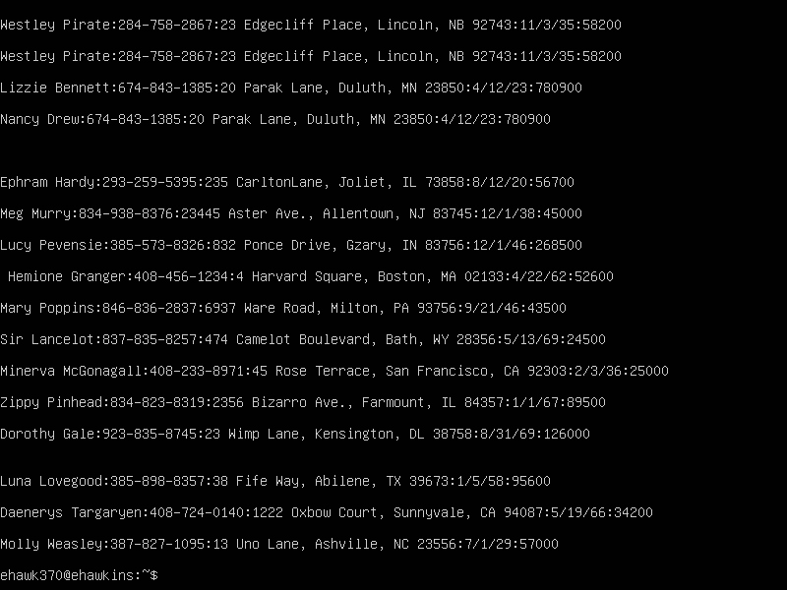

Sources

YouTube

Learning Modules Adrianna’s video https://youtu.be/lif-DjWYoWY

Chegg Study

Geeksforgeeks.org